CIS 2109 Lab 1

Scott O’Hara

1. VARCHAR2
2. CustomerName cannot be NULL, CustomerAddress can be NULL.

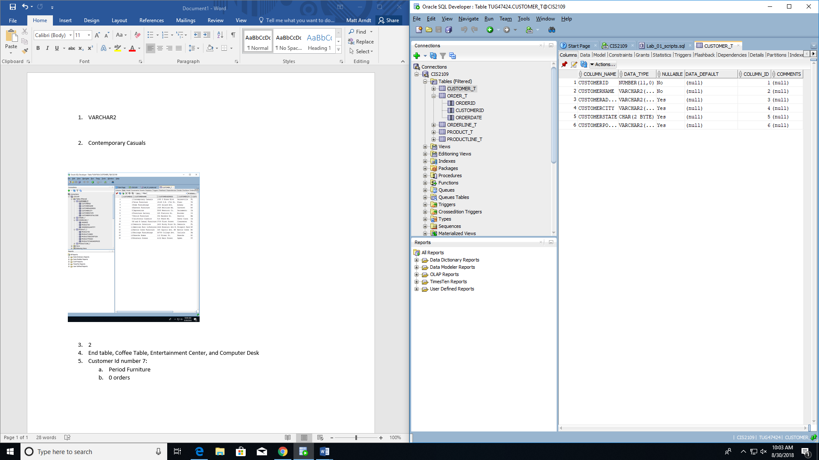

1. Contemporary Casuals

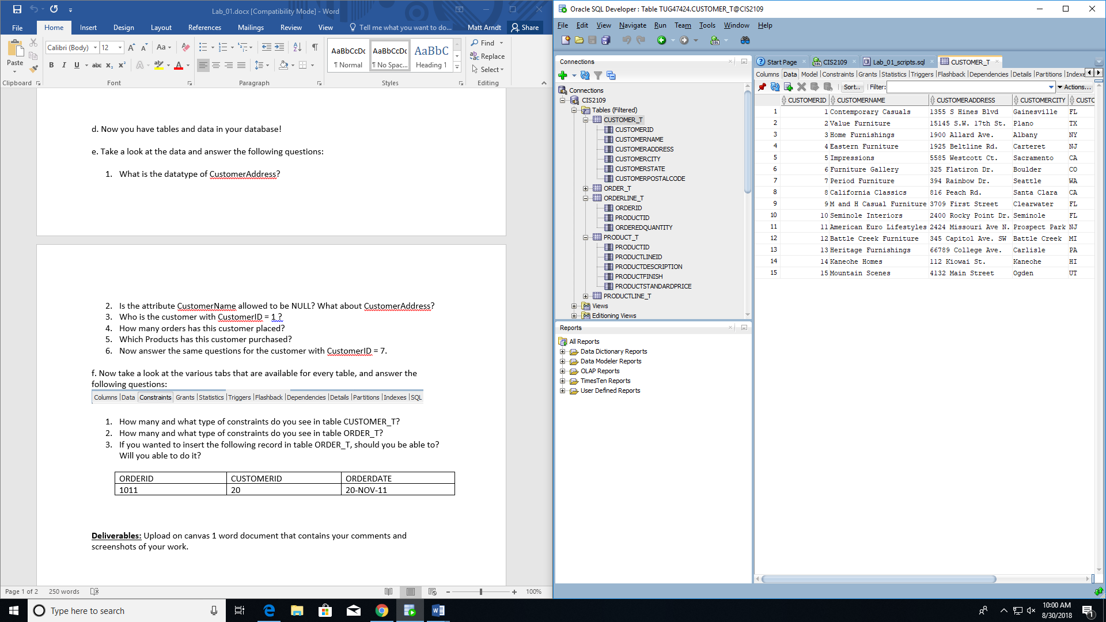

1. 2

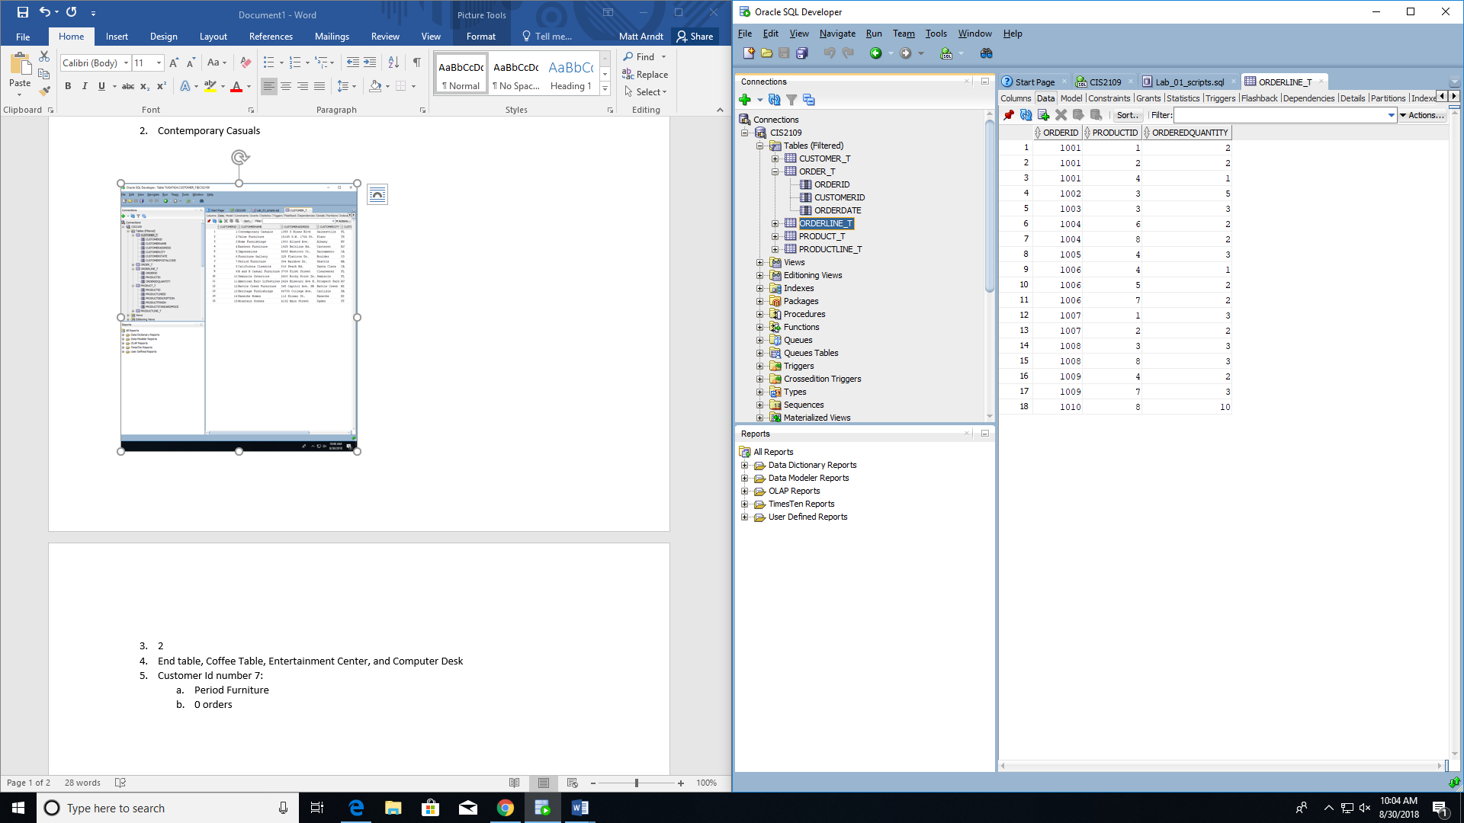

1. End Table, Coffee Table, Entertainment Center, Computer Desk

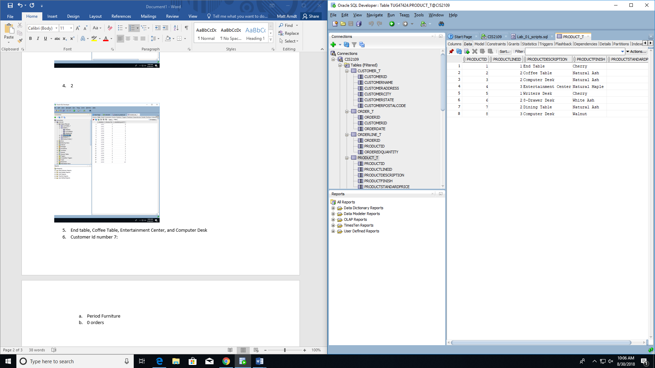

1. Customer ID = 7:
2. Period Furniture
3. 0
4. None

F)

1. 3 Constraints, Primary_Key and Check

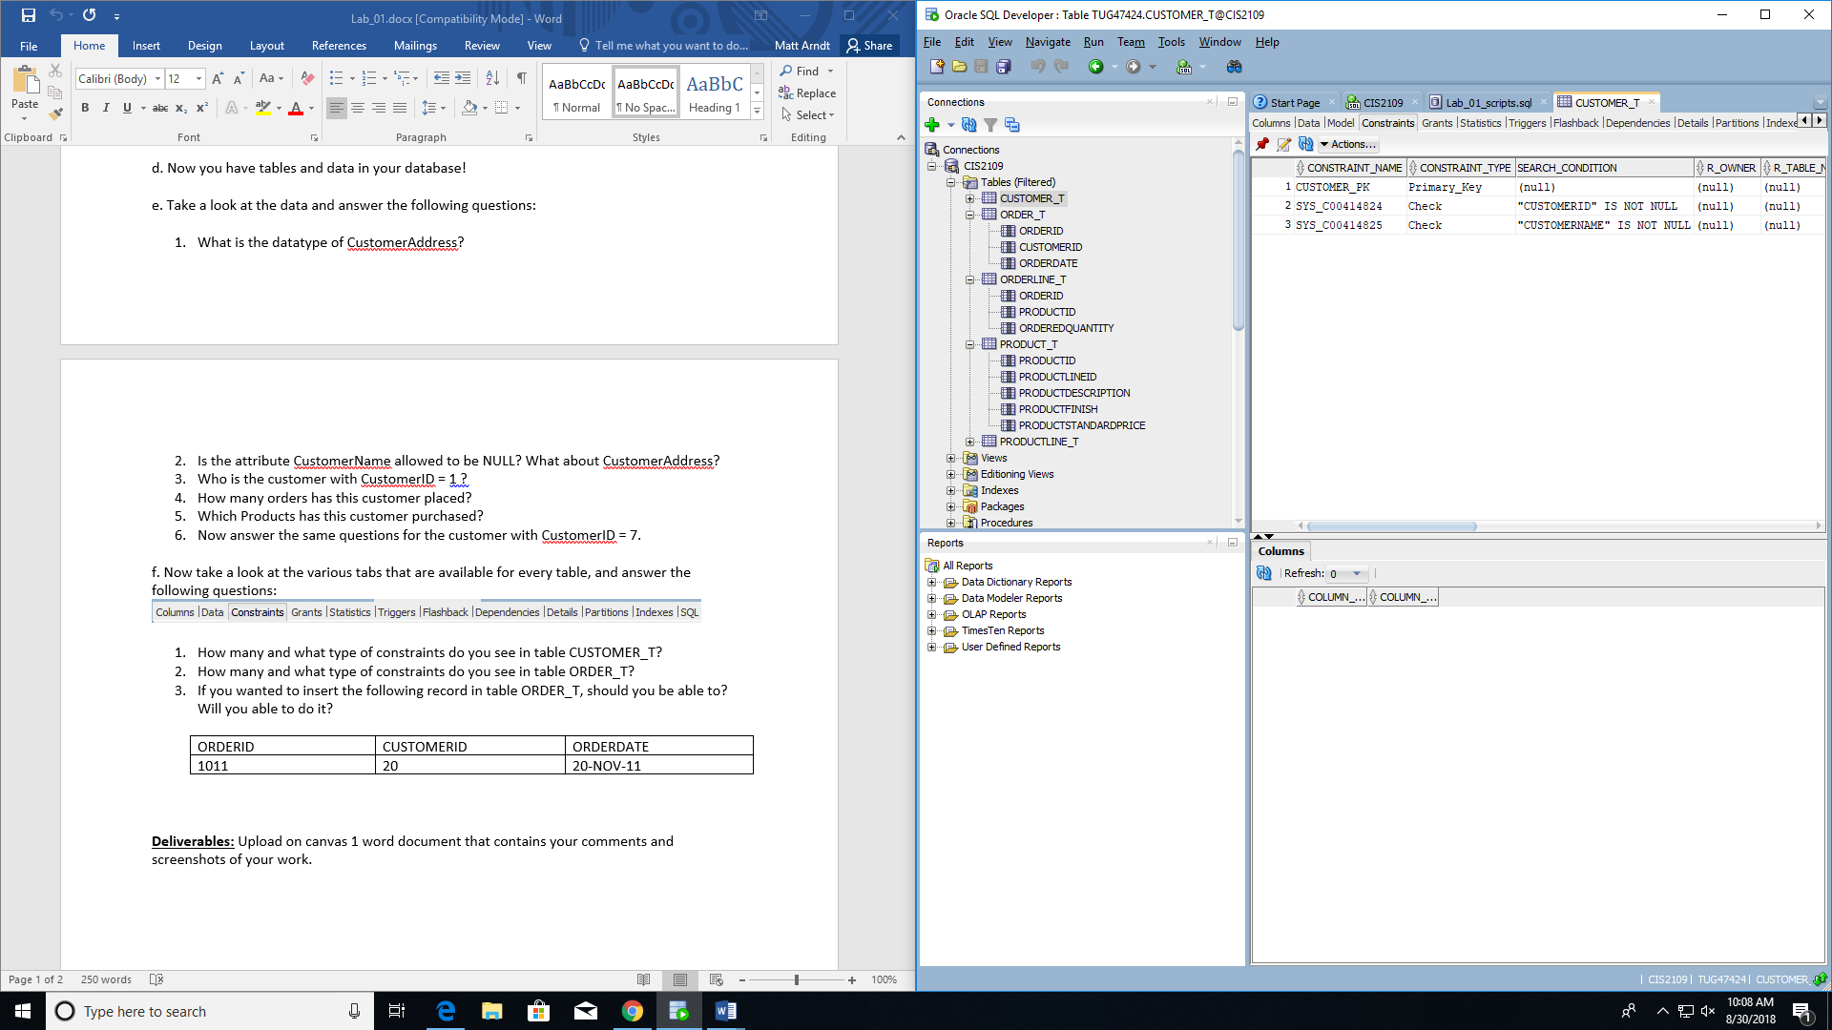

2. 3 Constraints, Foreign_Key, Primary_Key, and Check

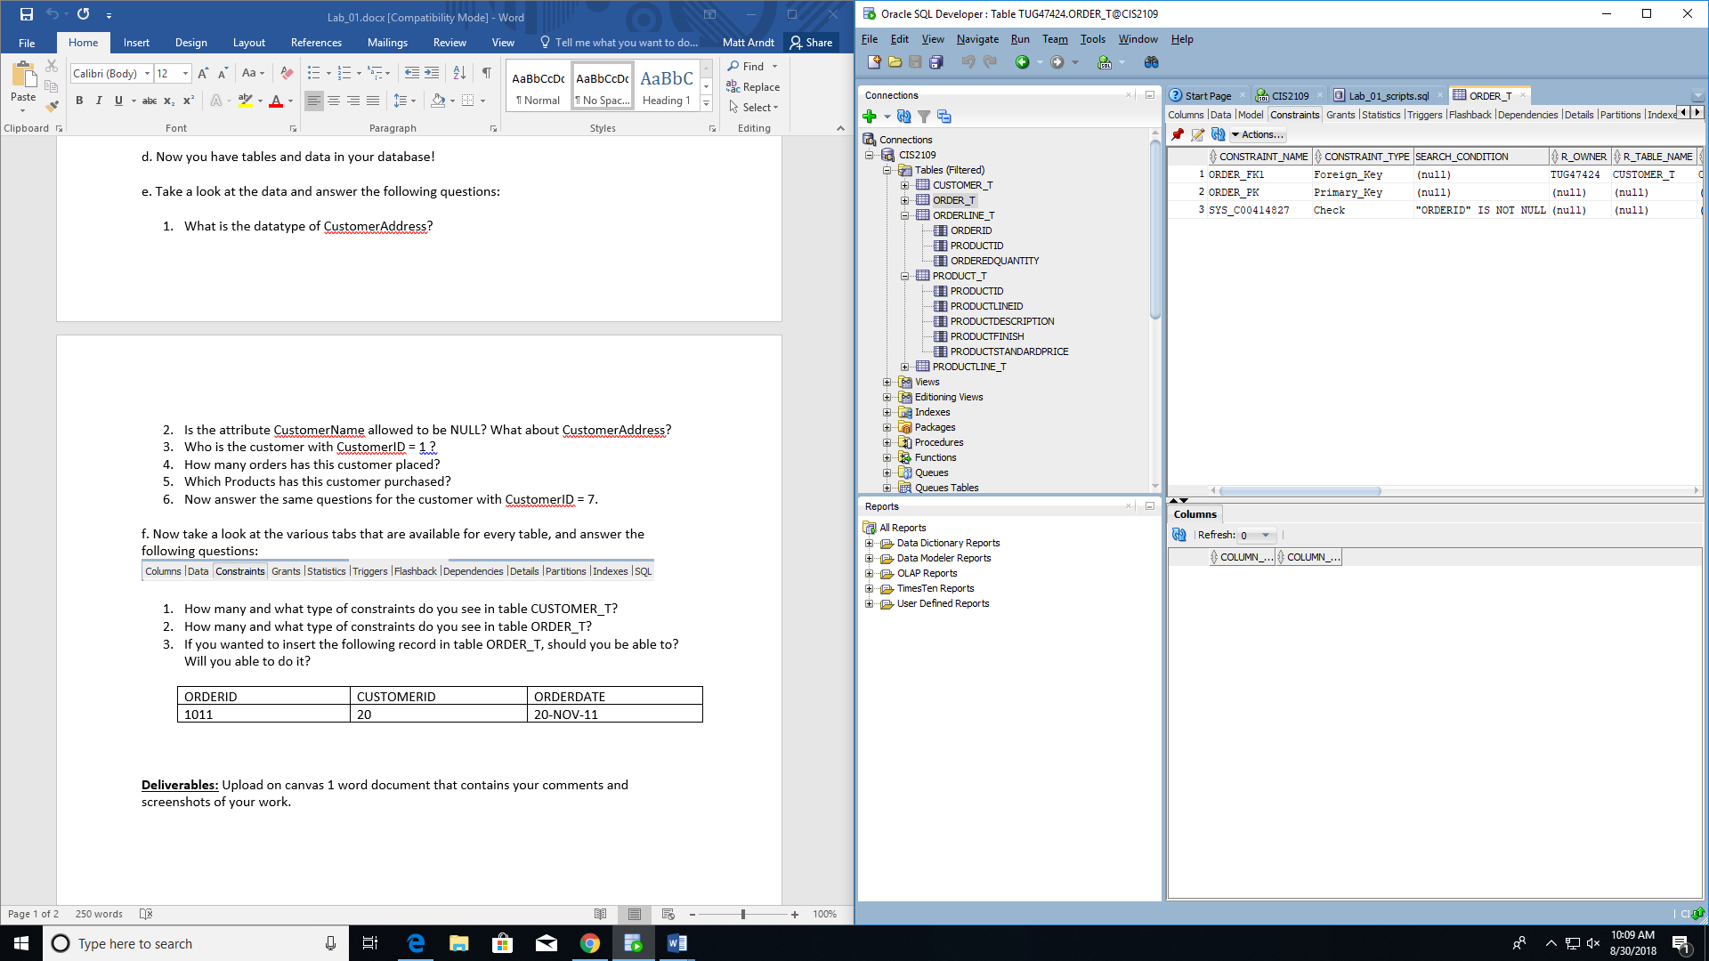

3. No, you won’t be able to, instead you will get an error. “The foreign key value has no matching primary key.” Also, you shouldn’t be able to.

